**STATEWISE AND CROPWISE ESTIMATES OF**

**VALUE OF OUTPUT FROM AGRICULTURE**

# STATEMENT 1

**STATEWISE VALUE OF PRODUCTION**

**(at current prices)**

**(PADDY)**

Ref:- [https://www.mospi.gov.in/](https://www.mospi.gov.in/sites/default/files/publication_reports/Statewise_2july21.pdf)

Ref:-<https://rbidocs.rbi.org.in/rdocs/Publications/PDFs/48T4785D849A48A4D1CB579FC38784FD3BC.PDF>

**Year (1980-91)**

|  |  |  |  |
| --- | --- | --- | --- |
| **year** | **Leading state** | **Lowest production** | **Total production(India)** |
| **1980-81** | **West Bengal** | **Daman & Diu** | **968770** |
| **1981-82** | **Andhra Pradesh** | **Daman & Diu** | **1100534** |
| **1982-83** | **Andhra Pradesh** | **Daman & Diu** | **1074092** |
| **1983-84** | **Andhra Pradesh** | **Daman & Diu** | **1473247** |
| **1984-85** | **West Bengal** | **Daman & Diu** | **1362636** |
| **1985-86** | **West Bengal** | **Daman & Diu** | **1565084** |
| **1986-87** | **West Bengal** | **Sikkim** | **1566078** |
| **1987-88** | **West Bengal** | **Daman & Diu** | **1687489** |
| **1988-89** | **West Bengal** | **Daman & Diu** | **2210796** |
| **1989-90** | **West Bengal** | **Sikkim** | **2383443** |
| **1990-91** | **West Bengal** | **Daman & Diu** | **2622786** |

**\*Summary:\***

**- *Andhra Pradesh* and *West Bengal* led in paddy production from 1980 to 1991 due to favorable climate, advanced agricultural practices, and government support.**

**- *Daman and Diu* consistently had the lowest production, likely due to less favorable climatic conditions and limited agricultural resources.**

**- Other regions like *Sikkim* and *Union Territories* such as *Delhi* and *Andaman and Nicobar Islands* also had low paddy production compared to Andhra Pradesh and West Bengal.**

**Rice Mini-Kit programme which was initiated during 1971-72 and continued up to 9th plan period. Thus, the percentage of area under high yielding varieties has been increased from 11.5% in 1969-70 to 79% during 1999-2000.**

**\*Due to which there has been steady growth from west Bengal in production of paddy.**

**Since 1991, West Bengal has been the leading state to produce highest amount of paddy in india**

[**https://agriexchange.apeda.gov.in/india%20production/India_Production.aspx?cat=fruit%26hscode=1056#**](https://agriexchange.apeda.gov.in/india%20production/India_Production.aspx?cat=fruit%26hscode=1056%23)

|  |  |  |
| --- | --- | --- |
| **1994-95:** | **76,975.3** | **Increase** |
| **1997-98:** | **86,076.7** | **Increase** |
| **1998-99:** | **89,682.9** | **Increase** |
| **2002-03:** | **93,340.0** | **Increase** |
| **2003-04:** | **71,820.2** | **Decrease** |
| **2006-07:** | **88,526.0** | **Increase** |
| **2009-10:** | **91,793.4** | **Increase** |
| **2012-13:** | **95,355.3** | **Increase** |
| **2013-14:** | **96,692.9** | **Increase** |
| **2014-15:** | **99,182.5** | **Increase** |
| **2018-19:** | **105,310.9** | **Increase** |
| **2019-20:** | **105,231.6** | **Decrease** |
| **2020-21:** | **106,645.5** | **Increase** |

In 2003, Production prospects for the 2003 season in the country remain extremely poor as drought conditions continue to prevail. equivalent, a level close to the all-time record realized in 1998. The upward adjustment reflects a higher estimate of exports by China, Thailand and India.

In 2019-20, Covid hit us hard even in cultivation therefore resulting in low productivity in paddy.

# STATEMENT 1

**STATEWISE VALUE OF PRODUCTION**

**(at current prices)**

**(WHEAT)**

**Ref:-**[**https://rbidocs.rbi.org.in/rdocs/Publications/PDFs/61T_15112023412D0551C2EE4D0A98B075BEDFCCA86E.PDF**](https://rbidocs.rbi.org.in/rdocs/Publications/PDFs/61T_15112023412D0551C2EE4D0A98B075BEDFCCA86E.PDF)

|  |  |  |  |
| --- | --- | --- | --- |
| **Year** | **State** | **Production (in tons)** | **India** |
| 1980-1981 | Uttar Pradesh | 178,827 | 523263 |
| 1981-1982 | Uttar Pradesh | 189,827 | 589923 |
| 1982-1983 | Uttar Pradesh | 241,555 | 732954 |
| 1983-1984 | Uttar Pradesh | 248,010 | 743937 |
| 1984-1985 | Uttar Pradesh | 247,484 | 734306 |
| 1985-86 | - | 275,899 | 839315 |
| 1986-87 | - | 282,946 | 813748 |
| 1987-88 | - | 324,012 | 940703 |
| 1988-89 | - | 391,326 | 1174100 |
| 1989-90 | - | 388,837 | 1154647 |
| 1990-91 | - | 494,644 | 1481181 |

* Throughout the period from 1980 to 1991, Uttar Pradesh consistently emerged as the foremost leader in wheat production, surpassing all other states in India. Following Uttar Pradesh, Punjab maintained a strong position as the second-largest producer of wheat, with notable contributions from Madhya Pradesh and Haryana as well.
* In contrast, during the same period, Tamil Nadu, Dadra and Nagar Haveli, Andaman and Nicobar Islands, and even Delhi emerged as the least productive regions for wheat cultivation, consistently reporting lower yields compared to other states in India.

From 1991 to the present day, Uttar Pradesh has maintained its unparalleled dominance as the primary wheat-producing state in India. Throughout this period, Uttar Pradesh has consistently demonstrated unwavering commitment to wheat cultivation, with no fluctuations in its production levels. There has been a steady and uninterrupted growth trajectory, showcasing Uttar Pradesh's enduring significance in contributing to India's wheat production landscape.

Ref:-<https://www.indexmundi.com/agriculture/?country=in&commodity=wheat&graph=production>.



The current agricultural crisis resembles the situation during the NDA government from 1997-2003, marked by falling prices and worsening conditions for farmers. This led to public dissatisfaction and a change in government in 2004. However, the current government hasn't learned from past mistakes and is facing a severe agricultural crisis again.

This was during NDA government therefore in 2003 there was a whooping decrease in production of crops (aprox-9.63%)



ANOTHER DEVASTATING EVENT…

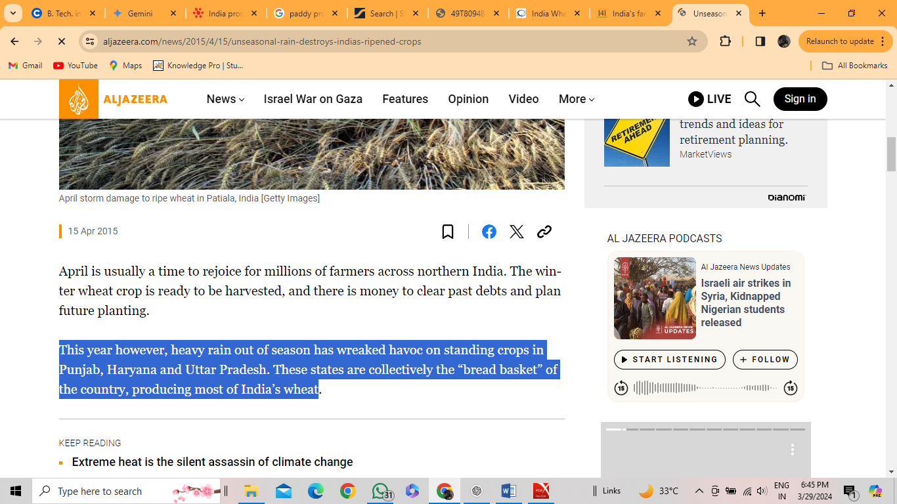

This was in 2015 where we faced trouble again in production of crops….

(Aprox -9.73%) due heavy rainfall in the northeastern region of india.

Ref:-<https://economictimes.indiatimes.com/news/economy/agriculture/cold-snap-helps-indias-wheat-crop-but-warm-weather-forecasts-pose-risk/articleshow/107228116.cms?from=mdr>

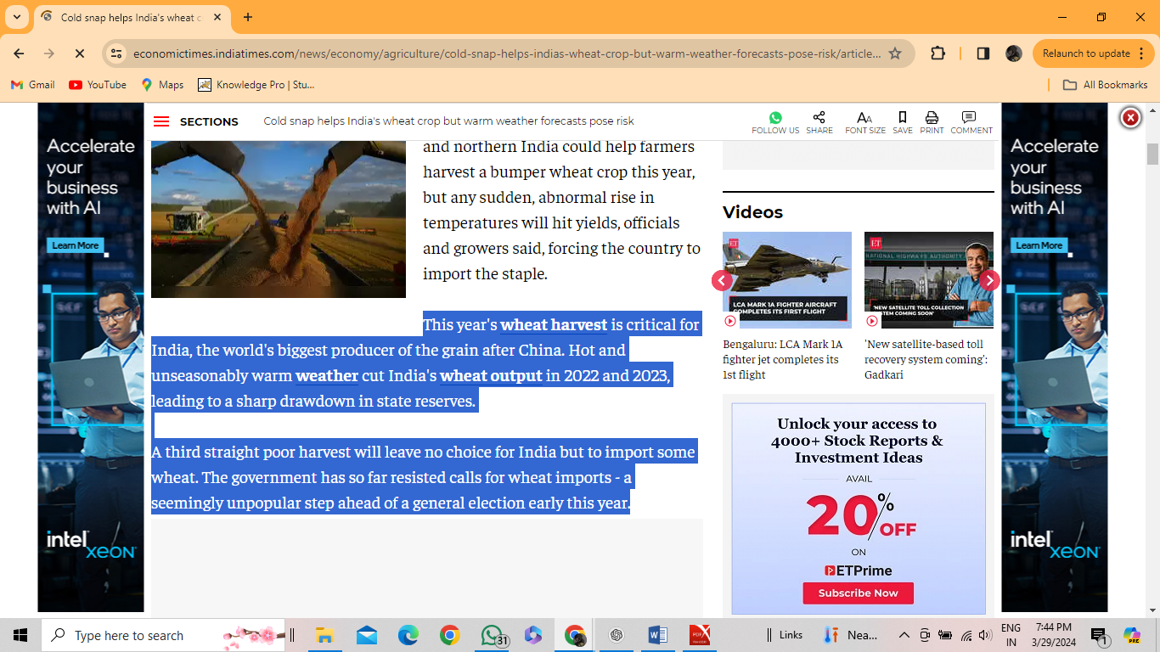

In the 2022-23 also India faced slight low productivity (aprox -5.10%) due to warm weather.